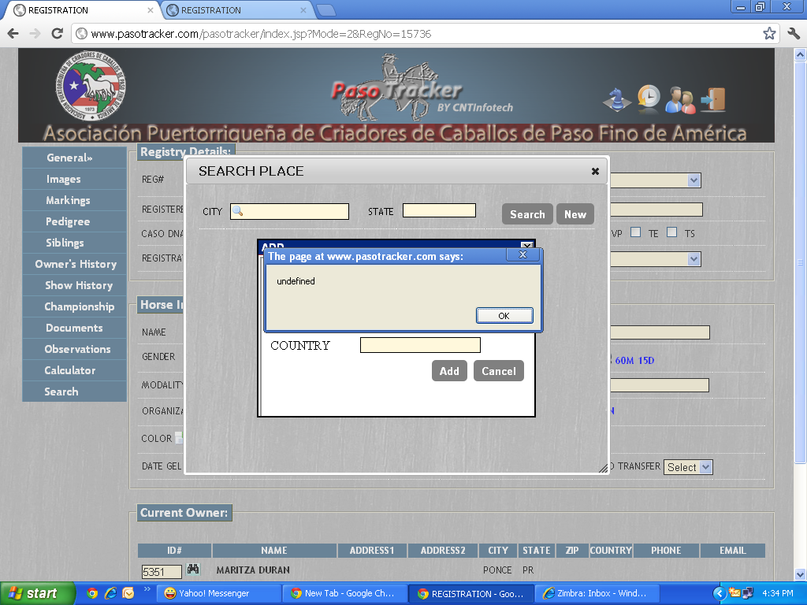
Issue 1: When I click on cancel in Add Place pop up….I am getting a pop up with the message “undefined”.

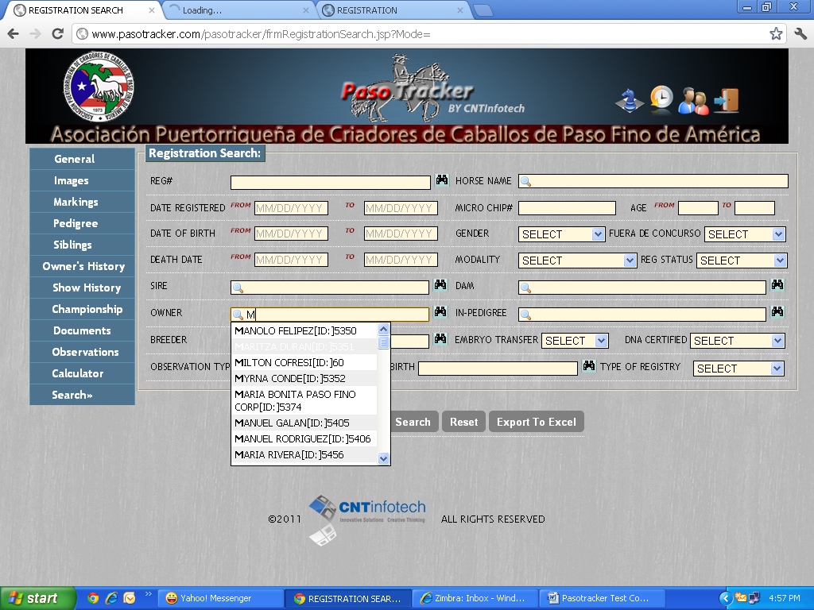
Issue 2: The color of the drop down hides the value chosen instead of highlighting the value chosen.

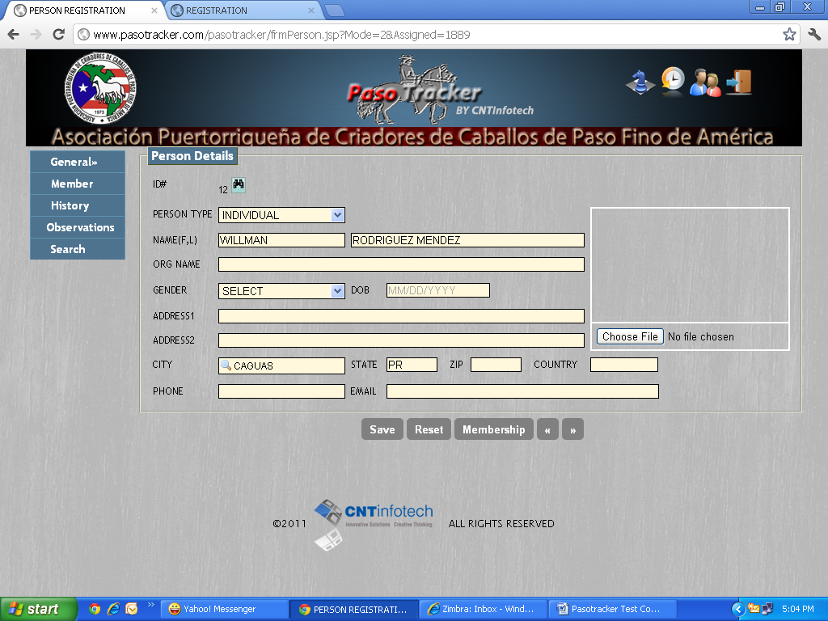
Issue 3: The >> next button is not functional in Person Details Screen.

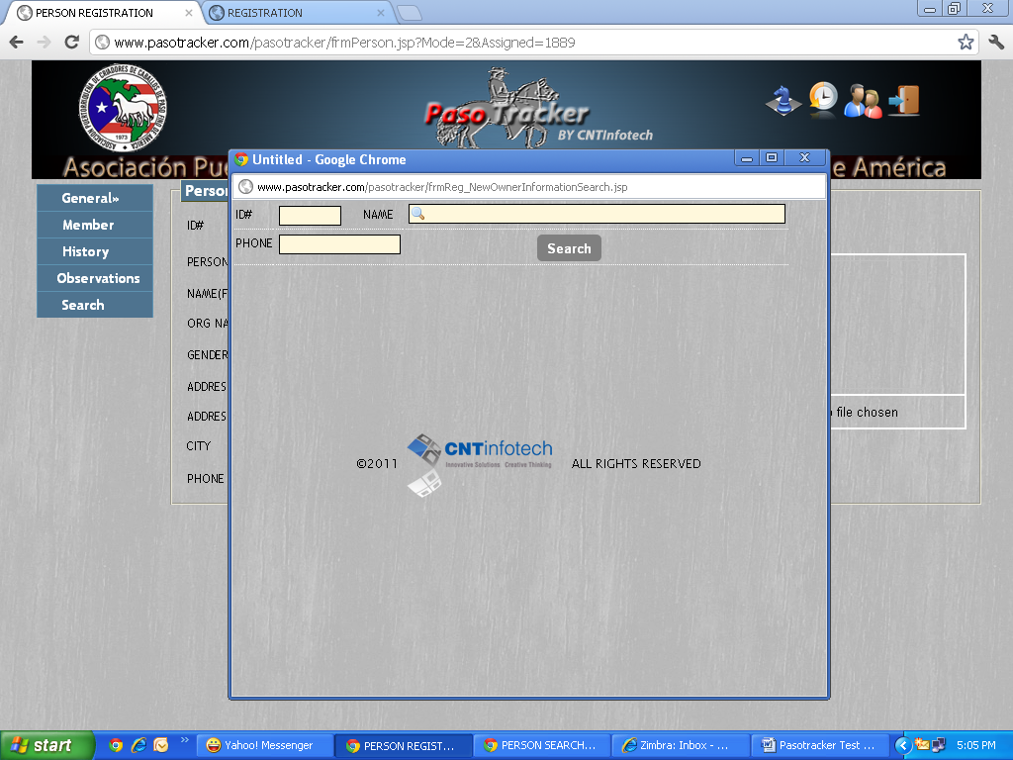
Issue 4: It does not show Person Search in the above person search pop up.

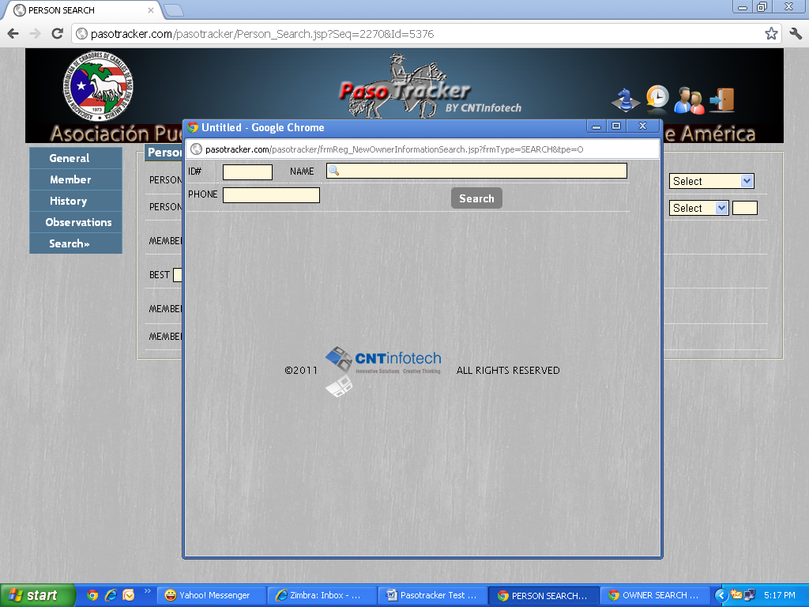
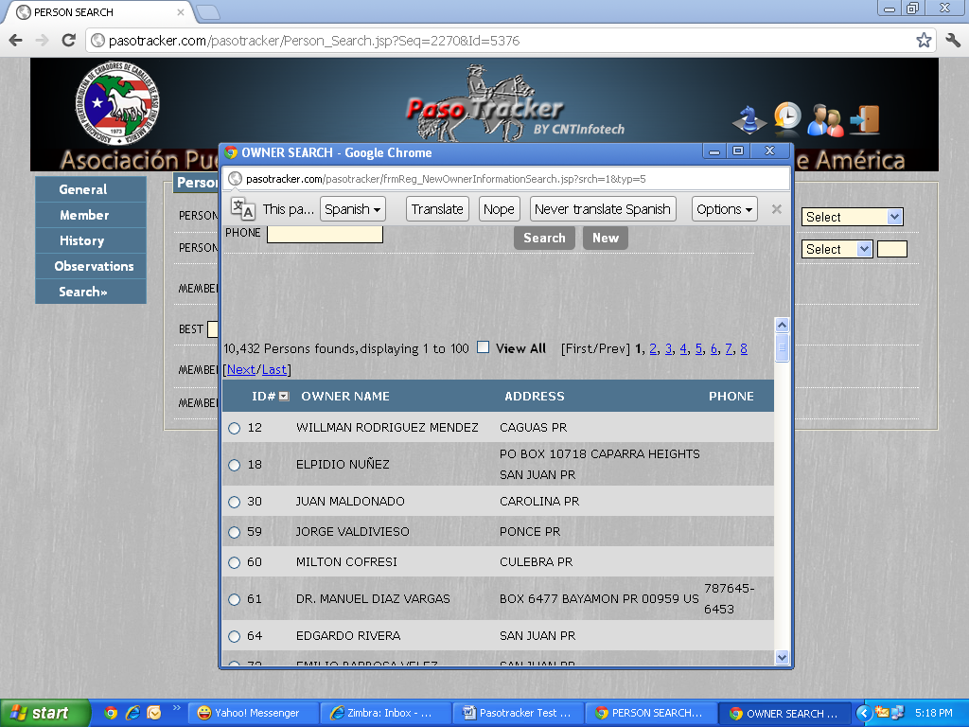
Issue 5: Only when I click on Search….does the New button show up in the person search pop up.
Issue 6: Why is the person search screen entitled as owner search.
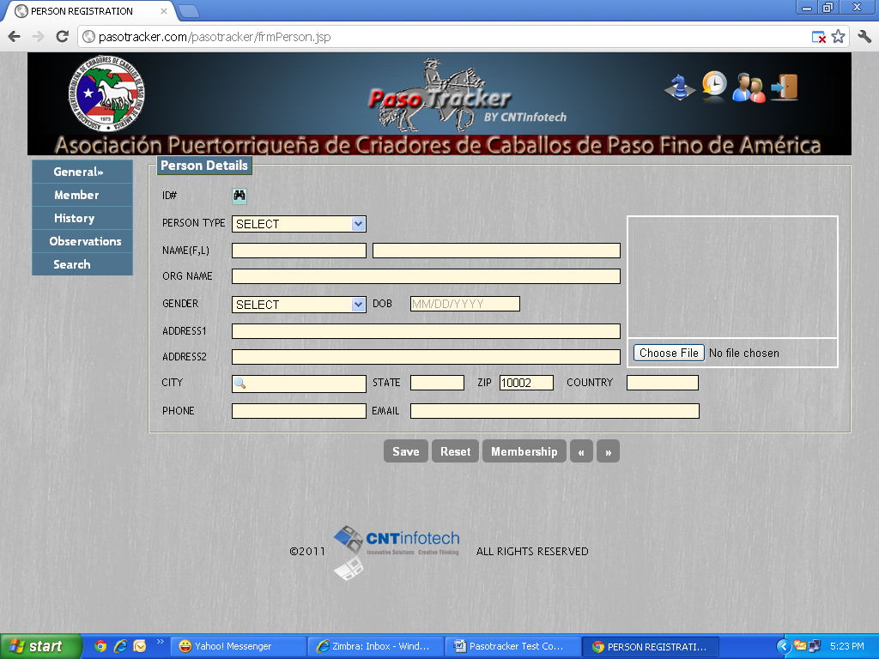
Issue 7: When I enter a zip code,….it does not show me a pop up with all the areas which pertain to that zip code.

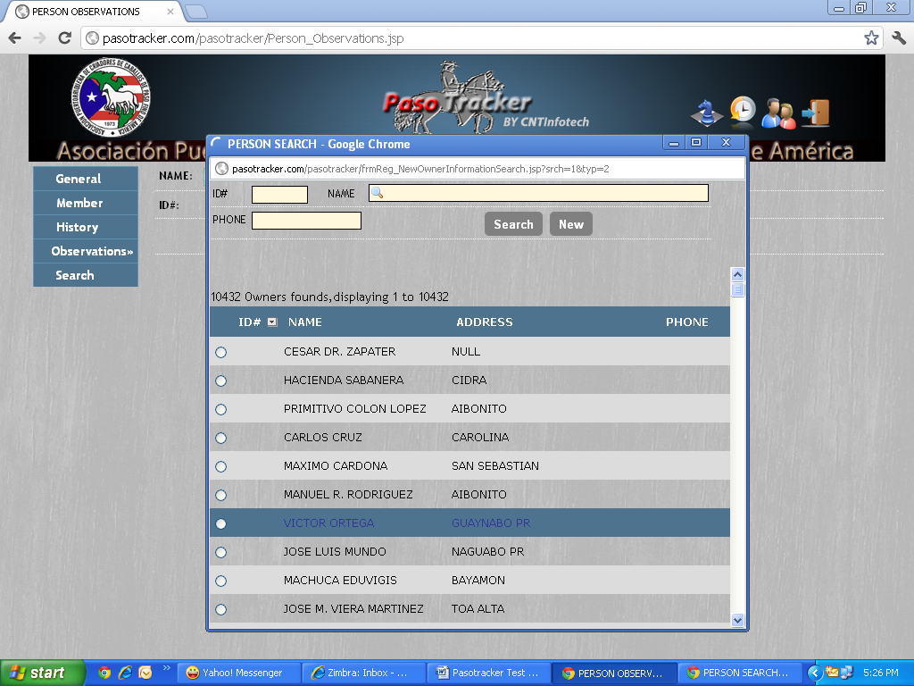
Issue 8: When I choose View All why is it not showing me the ID#’s of the members registered.

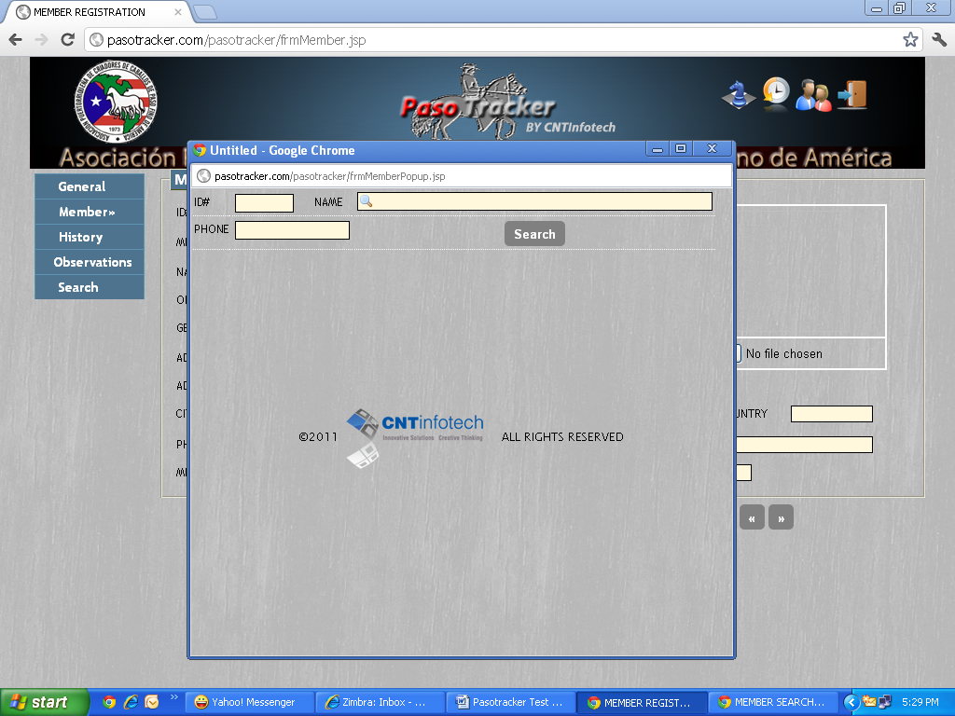
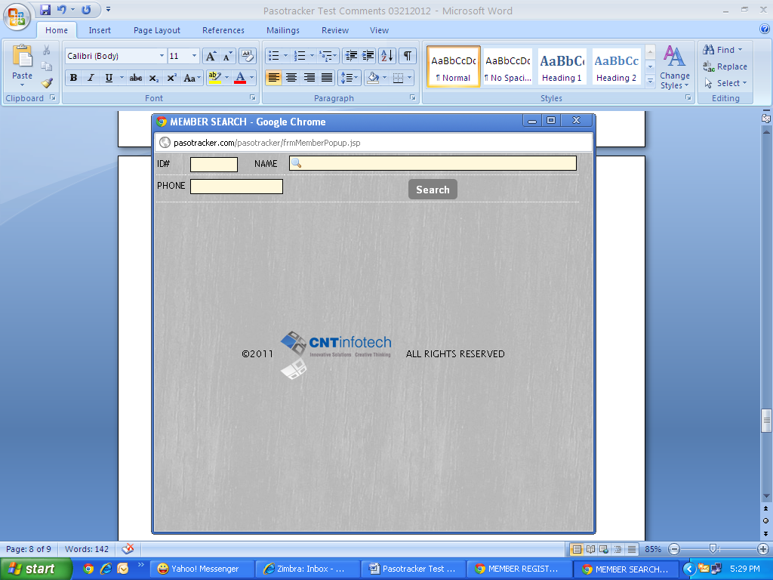
Issue 9: When I click on Member search binocular icon….2 pop ups open up…one with the wording Untitled and the other pop up entitled MEMBER SEARCH.

